The Carte de Visite

|  |  |
| --- | --- |
| Tau | 12+ |
| Taumata | 5 - 8 |

He aha te rauemi?

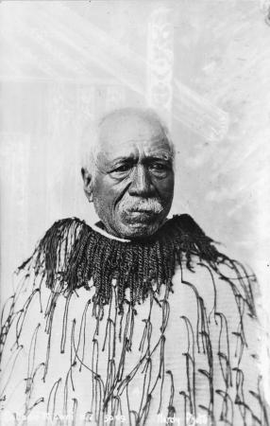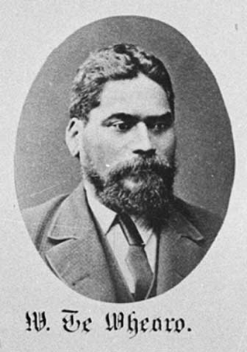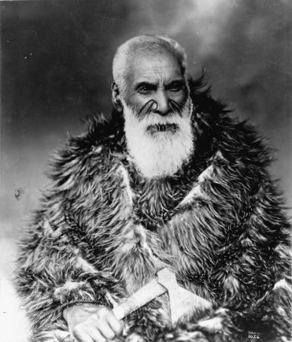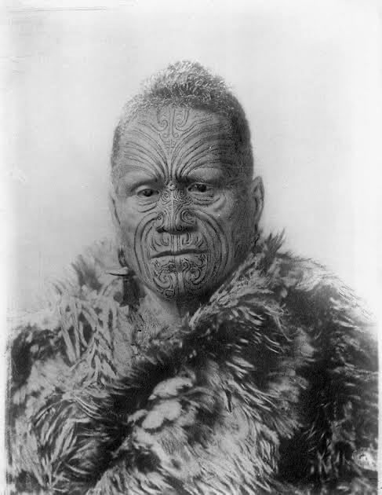

He pakimaero nā Hayden Tūroa nō Ngāti

Patutokotoko ki Whanganui mō te haerenga o

Kīngi Tāwhiao rātou ko Wiremu Te Pātara

Te Tuhi, Wiremu Te Mōrehu Maipapa

Te Wheoro, Tōpia Peehi Tūroa, Hori Ropiha

me tō rātou kaiwhakapākeha a George

Skidmore, ki Rānana i te tau 1884.

He hoaketanga kawe petihana ki te aroaro

tonu i a Kuīni Wikitoria mō ngā mahi raupatu

whenua a āna turupa ki Aotearoa heoti,

auare ake. Kāore a Kūini Wikitōria i paku aro

ki ngā Māori i tō rātou taenga atu ki Ingarangi.

Hei aha koa, e whakahira ana te pakimaero

nei i ngā hua nui me ngā wheako hou i puta

mai i tō rātou haerenga pērā i…

* Ngā mahi tōrangapū o taua wā
* Ngā whakaritenga mō te haerenga
* Te haerenga atu i Aotearoa ki Ingarangi mā Ahitereiria me Itāria
* Ko te rārangi wā me ngā kaupapa i whai wāhi atu ai rātou nō rātou i Rānana
* Te ‘Carte de Visite’
* Tōpia Peehi Tūroa e māuiui ana ki Rānana
* Te hononga i waenga i a Pōrangahau me Whanganui
* Ngā taumau
* Te hokinga mai ki Aotearoa

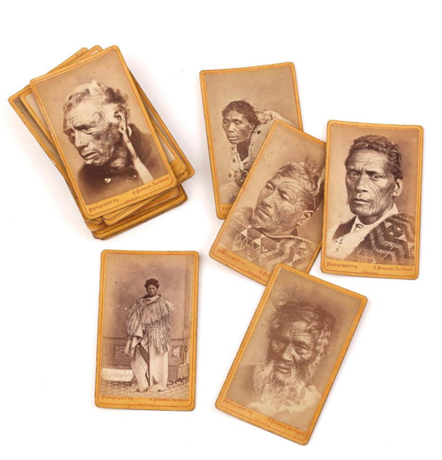

He aha koa te ‘Carte de Visite?’

Ko te ‘carte de visite’ he momo kāri whakaahua

tōririki rongonui i ngā wā ō mua. Nā

André-Adolphe-Eugène Disdér, he kaiwhakaahua

nō Wiwi i waihanga i ēnei kāri i te tau 1854. Inā

te maha o ngā whakaahua pēnei nei e whakaatu mai ana

ki roto i te pakimaero o ngā tūpuna e hōpara ana ki kōkei.

Whāinga

Kia mōhio ai ngā ākonga

Akoranga o mua

Ko te painga atu mehemea e mōhio ana ngā ākonga ki ētahi o ēnei kōrero o raro iho nei i mua i tā rātou pānui i te pakimaero…

* Te rere o te reo o Whanganui
* Te Tiriti o Waitangi
* Kīngitanga

Te hononga ki TMoA



Taumata 5–8

Ahakoa te pakeke me te taumata ako o ngā ākonga, ka taea e koe te tuitui i te whakamahinga o tēnei taupānga ki ngā wāhanga kaupapa o raro iho nei heoti, ka noho ko te Hauora te kaupapa matua mō ngā ngohe taunaki.

|  |  |  |  |  |  |
| --- | --- | --- | --- | --- | --- |
|  | TMoA |  | Whenu |  |  |
|  |  | Aho |  |
|  |  |  |  |  |  |
| Hauora | | | Tangata | Whanaungatanga | |
|  | Tikanga ā-iwi |  | Te Wāhi me te Taiao | Pāhekoheko / Matawhenua |  |
| Hangarau | | | Te Whakaharatau Hangarau | Te tāhiko me te hangarau whakatina | |
|  | Te Reo Pākeha | R | Āheinga Reo | Ā-Waha, ā-Tā, ā-Tinana |  |

Ngohe taunaki i te taupānga pāhekoheko



|  |  |  |  |
| --- | --- | --- | --- |
| Te Wāhanga  o TmoA | Te Whenu  Whāinga Paetae | Kawenga mā te kaiako | Tūmahi mā ngā ākonga |
| Hauora  Hononga:  Pāngarau  Ngā Toi  Tikanga ā-iwi  Te Reo | Tangata  Whanaungatanga  Ka whakamahi i ngā āhuatanga katoa o te  reo me te tinana hei whakatau tika i ngā take, hei whakawhitiwhiti whakaaro, kare ā-roto, me te mōhiohio. | Tirikawa  Kia toka tū moana ahakoa ngā piki me ngā heke o te wā. Kia mau whiwhia ki ngā taonga tuku iho.  Kēmu: [Kōruru](https://www.r2r.org.nz/games-activities-maori-youth/38-general/games-and-activities-for-maori-rangatahi/116-koruru-knuckle-bones.html)  Rauemi: Kia 5 ngā kōhatu pērā i te nui o te rua tāra  Tohutohu: Whakaritea ngā kōhatu hei Tirikawa tōriki. Kōrerohia ngā ture, te whāinga, ngā hua me ngā akoranga o te kēmu. Whakatauiratia ake te raupapatanga me ngā kupu mō ia nekehanga pērā i te, whiua, hopukina, tā…  Tukuna rātou kia tākaro! | Mahi ā-rōpū (Kaua e nui ake i te tokotoru mō tēnei kēmu.)  Whāinga: Kia oti pai ngā raupapatanga kōruru ka hoatu rā e te kaiako  Hua: te mahi tahi, kia raka ngā ringa me ngā karu, kia mānawanawa, kia manawanui, kia wawe te tautohe.  Akoranga: He rite ngā kōhatu kōruru ki a Tirikawa. Ahakoa ngā whiunga, ngā tukihanga, ngā karawhiunga, |
| Tikanga ā-Iwi  Hononga:  Te Reo:  (ā-waha)  Hauora  Ngā Toi | Te Wāhi me Te Taiao  Ka whakamārama i ngā whakaawenga o ngā tūāhua o mua i ngā hononga i roto, i waenga hoki, i te rōpū, me te haere tonu o ēnei whakaawenga | Karoro  Kia raungāwari, kia wawe te urutau i ngā āhuatanga o te wā  Kēmu: [Manu Tī](https://www.r2r.org.nz/games-activities-maori-youth/manu-ti.html)  Rauemi: He raukura me te tīpare mō ia ākonga  Tohutohu: Kōrerohia ngā ture, te whāinga, ngā hua me ngā akoranga o te kēmu. Hauruatia te akomanga, whakarārangihia kia rua ngā rārangi e anga whakaroto ana. Whakatauiratia ake me pēwhea.  Tukuna rātou kia tākaro | Mahi ā-rōpū: Takirua  Whāinga: Kia kapohia te raukura mai i te tīpare o tō hoa engari me kaua e neke ngā waewae, me pakiaka.  Hua: Whakapakaritia te hikohiko o te tinana, te aroā mokowā, te pānui i te tinana o tō hoa.  Akoranga: Kia raungāwari pērā i te karoro, kia wawe te urutau i ngā whiunga o te wā. |
| Te Reo  Hononga:  Ngā Toi  Tikanga ā-iwi  Hauora | Ā-Waha, Ā-Tā, Ā-Tinana  Ka whakamahi i ngā āhuatanga katoa o te  reo me te tinana hei whakatau tika i ngā take, hei whakawhitiwhiti whakaaro, kare ā-roto, me te mōhiohio. | Kawau  Mā te tirohanga whānui e pai ai te whakaemi raraunga me te whakamahere rautaki.  Kēmu: [Tī Uru](https://www.r2r.org.nz/games-activities-maori-youth/ti-uru.html)  Rauemi: ārai poho, kōeke whāriki, tī kouka/poi/pōro  Tohutohu: Kōrerohia ngā ture, te whāinga, ngā hua me ngā akoranga o te kēmu. Whakaatuhia te ataata mehemea kei te rangirua tonu ētehi. Karawhiua te pōro i te tuatahi kia waia ai ngā ākonga ki ngā ture o te kēmu. Wepua! | Mahi ā-rōpū  6 x kaitākaro  3 x kaitākaro ki ia tīma  Whāinga: Kia nui ake ngā piro mā te tango i ngā whāriki. Tirohia te hononga mō ngā tauira  Hua: whakaaro rautaki, kia raka ngā ringa me ngā karu, whanaungatanga, te aroā mokowā, kia taurite te tinana.  Akoranga: Kia whakamahere rautaki, kia huritao, kia whakaemi raraunga  . |
| Hangarau  Hononga:  Te Reo:  (ā-waha)  Pūtaiao  Pāngarau | Te Whakaharatau Hangarau  Ka rangahau, ka whakahiato i ōna hiahia hei mahere. Ka whakaarohia ēnei:  • he hātepe;  • ngā mātāpono;  • ngā momo rawa.  3. Ka whakamātau, ka aromātai i te otinga I runga anō i te āhua o:  • te hiahia, te huarahi wātea rānei;  • ngā rawa kua whakamahia;  • ngā mātāpono. | Haere ki te tōnga o te rā  Whāia te mātauranga me te māramatanga. Kaua e mataku ki te titiro ki waho.  Kēmu: [Kī-o-rahi](https://www.r2r.org.nz/games-activities-maori-youth/ki-o-rahi.html)  Rauemi: 1 x tupu, 7 x pou, pōro/kī, whīra, pou whenua  Tohutohu: Kōrerohia ngā ture, te whāinga, ngā hua me ngā akoranga o te kēmu. Whakaatuhia te ataata mehemea kei te rangirua tonu ētehi. Karawhiua te pōro i te tuatahi kia waia ai ngā ākonga ki ngā ture o te kēmu. Wepua! | Mahi ā-rōpū –  Whāinga: Kia nui ake ngā piro mā te pā i ngā pou mā te kī/pōro me te tupu. Tirohia te hononga mō ngā tauira.  Hua: whakapakari tinana, whakawhiti kōrero, mahi tahi, kia raka te mauī me te katau, te karo, te whiu me te kuru i te pōro, whakawhanaungatanga, pūkenga rautaki,  Akoranga: Kimihia, rangahaua ngā pūkenga, ngā pūmanawa o tēnā hoa, o tēnā hoa i tō tīma. Whakawhiti whakaaro me ngā mātauranga ki waenga i a koutou kia puāwai mai ai he rautaki toa. |

He rauemi tautoko



Pae tukutuku

Apanui and Tukaki

http://nzetc.victoria.ac.nz/tm/scholarly/tei-VUWMarae1986-t2-body-d4-d6.html

Nūpepa

Obit. New Zealand Herald. 2 Nov. 1895

Tāwhiao in England. New Zealand Herald. 10 Sept. 1884

Tāwhiao in London

https://paperspast.natlib.govt.nz/newspapers/NZH18840728.2.7

Pukapuka

Belgrave, Michael. Dancing with the king: The rise and fall of the King Country, 1864 - 1885. 1996.

Cowan, J. The New Zealand wars. Vol. 1, 1845-64. Wellington, 1922

Gorst, J. E. The Maori King. London, 1864

Grace, A F. Kingi Tāwhiao in England. Auck-Wai.Hist.JL. No.11 1967

Kirkwood, Carmen. Tāwhiao - King or Prophet. 2000.

Oliver, Steven. Te Tuhi, Wiremu Pātara, Dictionary of New Zealand Biography. 1990

Parsonson, Ann. Te Mana o Te Kingitanga Maori, 1972

Peneha, Pererika H. He kupu whakaatu. London: Glibert and Rivington, 1884.

Te Ara – The encyclopedia of New Zealand

Tāwhiao’s trip to London

<https://teara.govt.nz/en/photograph/24837/tawhiaos-trip-to-london>

Tōpia Peehi Tūroa

<https://teara.govt.nz/en/biographies/2t55/turoa-topia-peehi>

Wiremu Pātara Te Tuhi

<https://teara.govt.nz/en/biographies/1t78/te-tuhi-wiremu-patara>

Wiremu Te Mōrehu Maipapa Te Wheoro

<https://teara.govt.nz/en/biographies/1t87/te-wheoro-wiremu-te-morehu-maipapa>

Whare Pukapuka

Library of Waikato Museum

Alexander Turnbull Library

Ngaruawāhia Library

Whare Taonga

Auckland Technical Institute Museum

Public Whanganui Museum

Taranaki Museum

Matamata Historic Society (Inc)

Waikato Museum